## ***Requirement Gathering and analysis Phase***

## ***Technology Stack (Architecture & Stack)***

***Date :***27 July 2025

***Team ID:*** LTVIP2025TMID58557

***Project Name:*** FreelanceFinder

## ***TECHNICAL ARCHITECTUR***

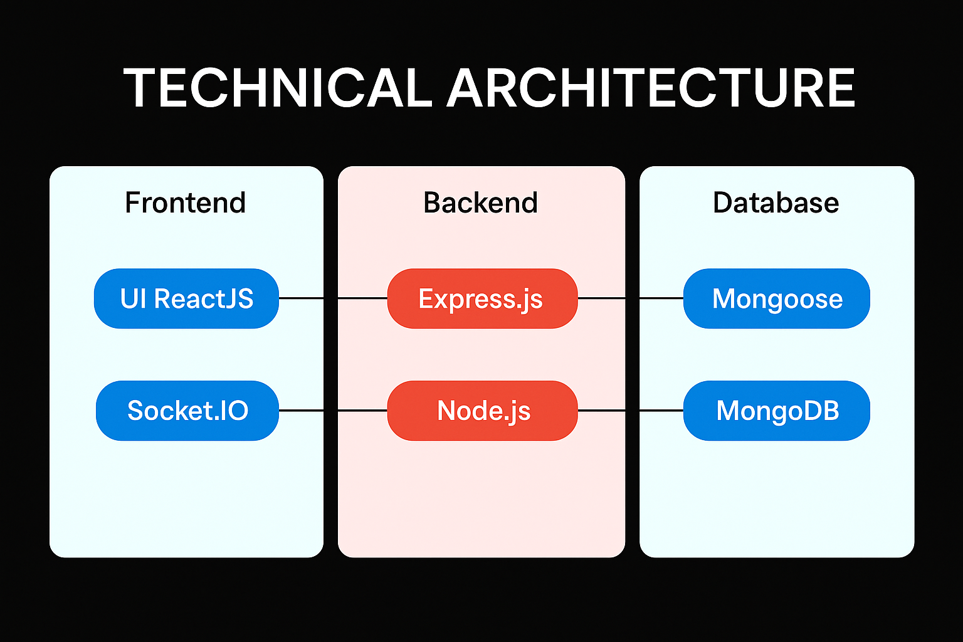

***Table-1: Components & Technologies***

| ***S.No*** | ***Component*** | ***Description*** | ***Technology Used*** |
| --- | --- | --- | --- |
| ***1*** | ***User Authentication & Registration*** | *Login, signup, JWT-based token auth* | *React, Node.js, Express, MongoDB, JWT* |
| ***2*** | ***Freelancer Profiles*** | *Create and manage freelancer data* | *React, Node.js, Express, MongoDB* |
| ***3*** | ***Project Posting*** | *Clients can post freelance projects* | *React, Node.js, Express, MongoDB* |
| ***4*** | ***Application Module*** | *Freelancers apply for jobs* | *React, Node.js, Express, MongoDB* |
| ***5*** | ***Chat System*** | *Real-time messaging between clients and freelancers* | *React, Node.js, Express, MongoDB, Socket.io* |
| ***6*** | ***Search and Filters*** | *Filter freelancers by skills, location, etc.* | *React, Node.js, Express, MongoDB* |
| ***7*** | ***Admin Dashboard*** | *Admin controls for monitoring users, posts, and reports* | *React, Node.js, Express, MongoDB* |
| ***8*** | ***Notifications*** | *Job status updates and application alerts* | *React, Node.js, Express, Firebase Cloud* |
| ***9*** | ***Resume Upload/File Storage*** | *Upload and download resume or work portfolio* | *React, Node.js, Express, MongoDB, Multer, AWS S3 (optional)* |
| ***10*** | ***Email Confirmation & Alerts*** | *Welcome emails, application success notifications* | *Node.js, Express, Nodemailer* |

***Table-2: Application Characteristics***

| ***S.No*** | ***Characteristics*** | ***Description*** | ***Technologies*** |
| --- | --- | --- | --- |
| ***1*** | ***Open-Source Frameworks*** | *Core frameworks and libraries* | *React, Node.js, Express, MongoDB, Socket.io, JWT* |
| ***2*** | ***Security Implementations*** | *Auth mechanisms, email verification, admin controls* | *JWT, OAuth, Nodemailer* |
| ***3*** | ***Scalable Architecture*** | *Follows 3-tier client-server architecture with reusable APIs* | *React, Node.js, Express, MongoDB* |
| ***4*** | ***Availability*** | *Can integrate with load balancers and auto-scaling on deployment platforms* | *Firebase Cloud, MongoDB Atlas* |
| ***5*** | ***Performance Optimization*** | *Caching, efficient DB querying, lazy loading* | *MongoDB indexing, RESTful APIs, AWS S3* |